**File Creation Task**

**1.Create directory**

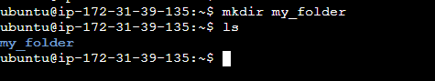

**Changing the directory and creating two files**

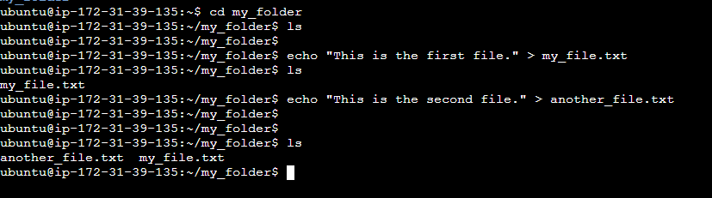

**Concatenate the file**

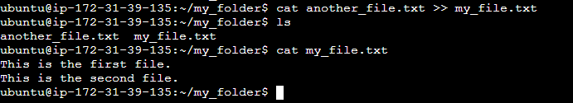

**Listing the files in current directory**

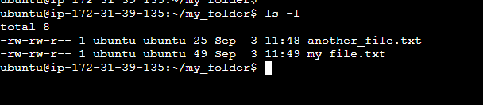

**2.**

**Creating 20 files with txt**



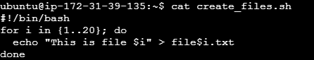

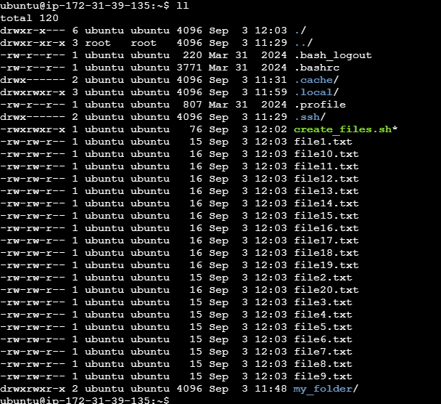

**Changing 5 .txt files to .yml files**

